**MANIPUR STATE LEGAL SERVICES AUTHORITY**

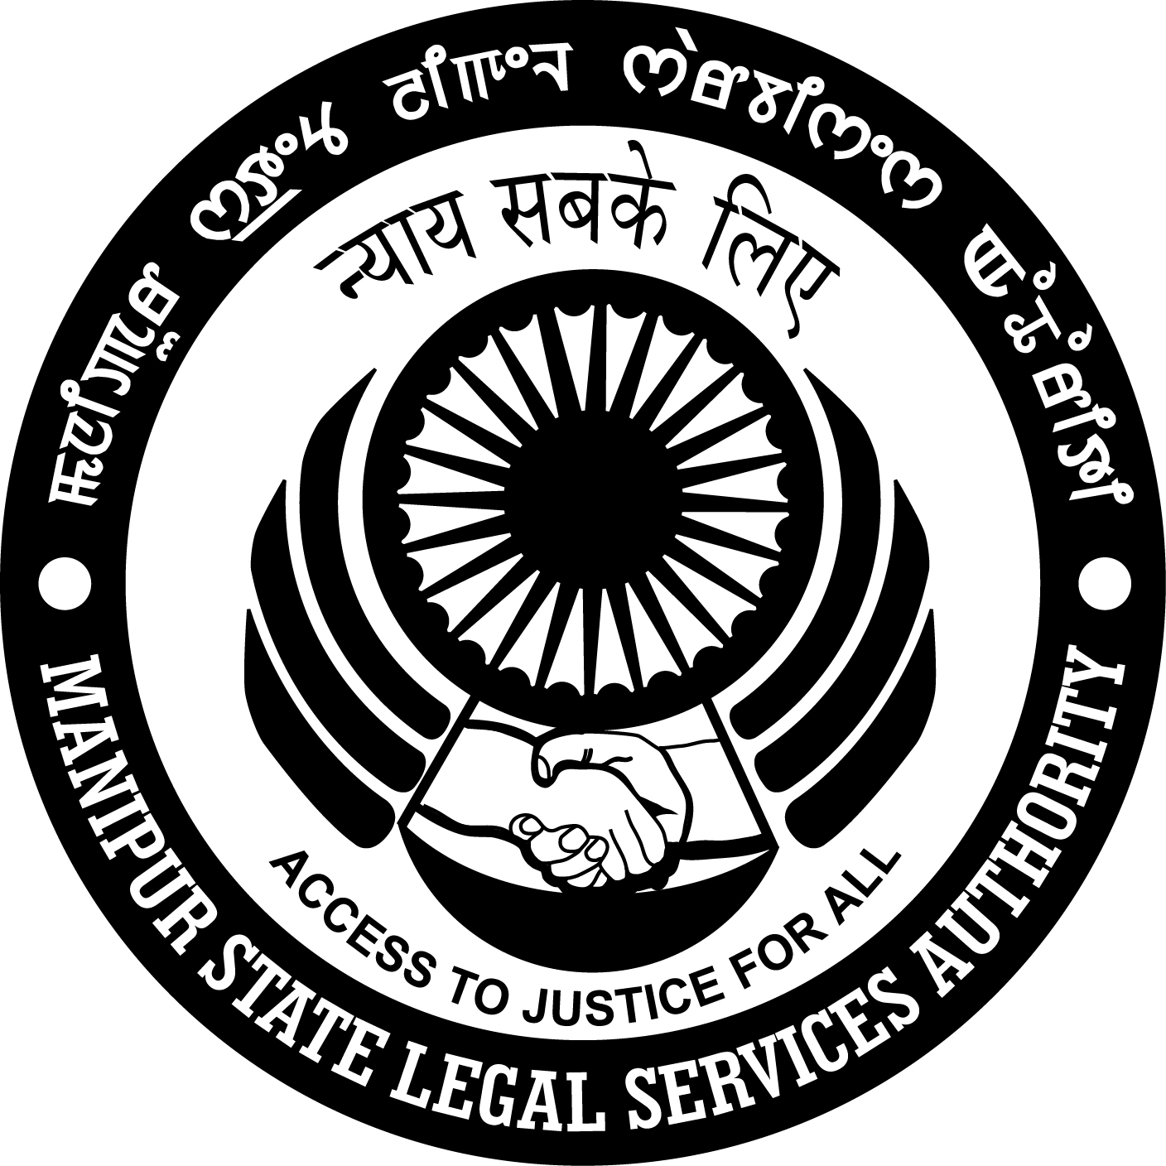

**FAQ**

**On**

**Consumer Protection Act, 1986 (68 of 1986)**

Printed and distributed by

**“Manipur State Legal Services Authority”**

*for information and awareness of the public*.

Year of printing :- 2016

No. of copies :- 10,000/- (Ten Thousand)

**Q. What does Consumer Disputes include?**

Ans :- Consumer Disputes includes :

1. Unfair Trade Practice.
2. Banking Service
3. Insurance Service
4. Postal Service
5. Medical Negligence
6. Education Service
7. Railway Service
8. Telephone Service
9. Transport Service
10. Tour and Travel Service
11. Agriculture Service
12. Mobile Phone Service
13. Housing and Construction Service
14. Professional Service including the service of legal practitioner.

**Q. Where can complaints in respect of the above disputes may be filed?**

Ans:- Complaints in respect of the above disputes may be filed in the following Courts/ Fora according to the valuation of the case and territorial jurisdiction :

1. **District Consumer Dispute Redressal Forum** :
2. At Sangaiprou, Imphal (for the Districts of Imphal East, Imphal West, Senapati and Ukhrul)
3. At Thoubal (for the Districts of Thoubal and Chandel)
4. At Bishnupur (for the District of Bishnupur and Churachandpur)

Where the value of goods or sources and compensation does not exceed Rs. 20 lakhs, the complaint may be filed in the above Forums according to the territorial jurisdiction.

1. **State Consumer Disputes Redressal Commission at Imphal.**

Where the value of goods or services and compensation claim exceed Rs. 20 lakh upto 1 crore, the complaint may be filed in the State Commission for the whole territory of the state of Manipur.

State Commission also entertains Appeal and Revision against the order of the District Forums.

1. **National Comsumer Disputes Redressal Commission at New Delhi.**

Where the value of goods or services and compensation, if any, claim exceeds 1 crore, the complaint may be filed in the National Commission for the whole territory of India.

National Commission also entertains Appeal and Revision against the order of the State Commissions.

***Courtesy :- Member, Manipur State Consumer Disputes Redressal Commission (State Commission), Imphal, Manipur.***

**MANIPUR STATE LEGAL SERVICES AUTHORITY**

**(A Statutory Body constituted under Section 6 of Legal Services Authority Act, 1987)**

High Court of Manipur Complex, Mantripukhri, Imphal.

Telefax: 0385-22413552, Free Helpline No. 9436239700,

e-mail: [maslsa.imphal@gmail.com](mailto:maslsa.imphal@gmail.com)

**FREE AND COMPETENT LEGAL AID**

***AIMS & OBJECTS:*** *To provide free and competent legal Service to the weaker sections of the society to ensure that opportunities for securing justice are not denied to any citizen by reason of economic or other disabilities and to organise Lok Adalats to secure that the operation of the legal system promotes justice on a basis of equal opportunity.*

**“LEGAL SERVICES” includes the rendering of any service in the conduct of any case or other legal proceeding before any court or other authority or tribunal and the giving of advice on any legal matter.**

**THESE SERVICES ARE PROVIDED BY WAY OF:**

* Providing Advocates at State expense;
* Paying court fee on behalf of the eligible persons;
* Bearing expenses regarding preparation of documents;
* Paying expenses for the summoning of witnesses; and
* Paying other incidental expenses connected with litigation

**PERSONS ELIGIBLE TO RECEIVE FREE LEGAL SERVICES:**

* A member of Schedule Caste/Schedule Tribe; or
* A victim of trafficking in human being or ‘begar’ as referred in Article 23 of the Constitution; or
* A woman or child; or
* A mentally ill or otherwise disabled person; or
* A victim of mass disaster, ethnic violence, caste atrocity, flood, drought, earthquake or industrial disaster; or
* An industrial workman; or
* A person in custody including protective home, juvenile home psychiatric hospital, psychiatric nursing home; or
* A person having annual income not exceeding Rs. 1,00,000/-

**FUNCTION:**

* To organize Lok Adalat to settle pending and yet to be initiated case (i.e. pre-litigation)
* To organize legal awareness and legal literacy programme through out the State on varied subjects in collaboration with local clubs, NGO’s under the aegis of District Legal Services Authority;
* To establish Legal Aid Clinic to spread legal awareness in far flung areas.

**HOW TO & WHOM TO APPLY:**

* Eligible person may apply to the Member Secretary, Manipur Legal Services Authority or Secretary, High Court of Manipur Legal Services Committee or Chairman/Secretary, District Legal Services Authority stating brief fact of the case and copies of relevant documents, of any, with an affidavit. CJM’s are the secretaries for their respective District LSAs.

**For assistance please contact:**

**MANIPUR STATE LEGAL SERVICES AUTHORITY**

(High Court of Manipur Complex, Mantripukhri – 795002, Imphal)

Contact : +91 9436239666; +91 9436239700 Email : [maslsa.imphal@gmail.com](mailto:maslsa.imphal@gmail.com)

1. **Secretary, High Court Legal Services Committee, High Court of Manipur.**

**District Legal Services Authorities:**

1. Secretary, Imphal West District Legal Services Authority cum CJM, Imphal West, Uripok Cheirap Court Complex, Imphal.
2. Secretary, Imphal East District Legal Services Authority, cum CJM, Imphal East Lamphel Court Complex, Lamphelpat.
3. Secretary, Bishnupur District Legal Services Authority, cum CJM, Bishnupur, Bishnupur Court Complex.
4. Secretary, Thoubal District Legal Services Authority, cum CJM, Thoubal, Thoubal Court Complex.
5. Secretary, Senapati District Legal Services Authority, cum CJM, Senapati, Senapati Court Complex.
6. Secretary, Ukhrul District Legal Services Authority, cum CJM, Ukhrul, Ukhrul Court Complex.
7. Secretary, Churachandpur District Legal Services Authority, cum CJM, Churachandpur, CCPUR Court Complex.
8. Secretary, Tamenglong District Legal Services Authority, cum CJM, Tamenglong, Lamphel Court Complex, Lamphelpat.
9. Secretary, Chandel District Legal Services Authority, cum CJM, Chandel, Chandel Court Complex.