MANIPUR STATE LEGAL SERVICES AUTHORITY

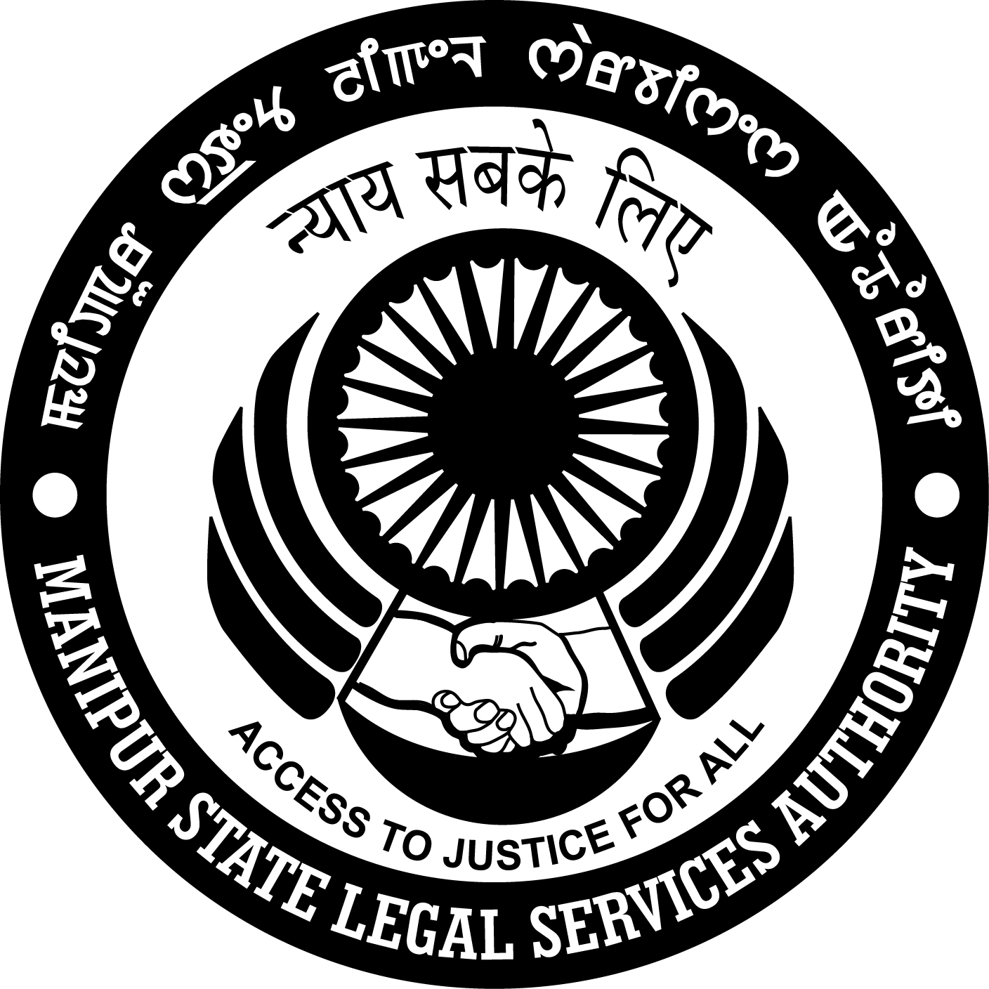

**INFORMATION BOOKLET**

***On***

**“PROHIBITION OF CHILD MARRIAGE ACT, 2006”**

***Published for the awareness of the people by***

***Manipur State Legal Services Authority on 8th March, 2017.***

**Implementation of Child Marriage Prohibition Act 2006**

          Child marriage is a gross violation of human rights that puts young girls at risk. A marriage where either of the contracting party is a child is considered as child marriage. Child or minor under this law is defined as 18 years in case of girls and 21 years in case of boys.

All children have right to care and protection, to develop and grow into a complete and full individual, regardless of their social and economic situation. Child marriage denies children their basic rights to good health, nutrition, education and freedom from violence, abuse and exploitation. The following Questions and Answers are prepared on **Child Marriage Prohibition Act 2006**for the awareness of the public:-

Q. What is meant by ***Child*** ?

*Ans:-****" Child*** " means a person who, if a male, has not completed twenty-one years of age, and if a female, has not completed eighteen years of age.

 Q.      What is meant by "***Child marriage***?

*Ans:-*"***Child marriage*** " means a marriage to which either of the contracting parties is a child.

 Q.      What is meant by "***contracting party***"?

 Ans:-*“****Contracting party”*** in relation to a marriage, means either of the parties whose marriage is or is about to be thereby solemnized.

Q. What is meant by "***Child Marriage Prohibition Officer***"?

Ans:-  "***Child Marriage Prohibition Officer***" are Officers appointed under sub-section (1) of section 16(I) of the Act.

Q. What is "***District court***"?

Ans:- " ***District court*** " means, in any area for which a Family Court established under section 3 of the Family Courts Act, 1984 exists, such Family Court, and in any area for which there is no Family Court but a city civil court exists, that court and in any other area, the principal civil court of original jurisdiction and includes any other civil court which may be specified by the State Government, by notification in the Official Gazette, as having jurisdiction in respect of the matters dealt with in this Act.

Q. What is meant by "***minor***"?

Ans:- "***Minor***" means a person who, under the provisions of the Majority Act,

1875 is to be deemed not to have attained his majority.

Q. What is the legal status of a **child marriage**?

Ans:- Every child marriage, whether solemnised before or after the commencement of this Act, shall be **voidable** at the option of the contracting party who was a child at the time of the marriage. Voidable means it can be declared void or annulled at the option of the contracting party.

 (or void from the outset) and unenforceable.

Q. Who can file a petition for annulling a **child marriage**?

Ans:-    A petition for annulling a child marriage by a decree of nullity may be filed in the district court only by a contracting party to the marriage who was a child at the time of the marriage. If at the time of filing a petition, the petitioner is a minor, the petition may be filed through his or her guardian or next friend along with the Child Marriage Prohibition Officer. The petition may be filed at any time but before the child filing the petition completes two years of attaining majority.

Q. What orders can also be passed by the **District Court**?

Ans:-     While granting a decree of nullity, the **District Court** shall make an order directing both the parties to the marriage and their parents or their guardians to return to the other party, his or her parents or guardian, as the case may be, the money, valuables, ornaments and other gifts received on the occasion of the marriage by them from the other side, or an amount equal to the value of such valuables, ornaments, other gifts and money.

While granting a decree under section 3, the **District Court** may also make an interim or final order directing the male contracting party to the child marriage, and in case the male contracting party to such marriage is a minor, his parent or guardian to pay maintenance to the female contracting party to the marriage until her remarriage.

Q. What shall be the quantum of **maintenance**?

Ans:- The quantum of **maintenance** payable shall be determined by the district court having regard to the needs of the child, the lifestyle enjoyed by such child during her marriage and the means of income of the paying party. The amount of maintenance may be directed to be paid monthly or in lump sum.

In case the party making the petition under section 3 is the female contracting party, the **District Court** may also make a suitable order as to her residence until her remarriage.

Q. What about the custody and maintenance of any children of child marriage?

Ans:-   Where there are children born of the child marriage, the **District Court** shall make  an appropriate order for the custody of such children of child marriages. While making an order for the custody of a child under this section, the welfare and best interests of the child shall be the paramount consideration to, be given by the **District Court**. An order for custody of a child may also include appropriate directions for giving to the other party access to the child in such a manner as may best serve the interests of the child, and such other orders as the district court may, in the interest of the child, deem proper.

The **District Court** may also make an appropriate order for providing maintenance to the child by a party to the marriage or their parents or guardians.

**Notwithstanding that a child marriage has been annulled by a decree of nullity under section 3, every child begotten or conceived of such marriage before the decree is made, whether born before or after the commencement of this Act, shall be deemed to be a legitimate child for all purposes**.

Q. To which **District Court** application for the reliefs should be filed?

Ans:- For the purpose of grant of reliefs under sections 3, 4 and 5, the application may be filed to the district court having jurisdiction over the place where the defendant or the child resides, or where the marriage was solemnised or where the parties last resided together or the petitioner is residing on the date of presentation of the petition.

Q. Is there any provision for punishment of an adult contracting marriage with a child under this Act?

Ans:- Yes. If a male adult above eighteen years of age, contracts a child marriage, he shall be punishable with **rigorous imprisonment which may extend to two years** **or with fine which may extend to One Lakh** **Rupees or with both**. The offence is **cognizable** and **non-bailable**.

**\*Cognizable offence** means an offence where a police officer can investigate or make an arrest without the order or warrant of the court.

**\*Non bailable offence** means an offence where grant of bail cannot be claimed as a matter of right by the accused.

Q. Is there any provision for **punishment for solemnizing** a child marriage?

Ans:- Yes. Whoever **performs, conducts, directs or abets** any child marriage shall be punishable with rigorous imprisonment which may extend to **two years** and shall be liable to fine which may extend to **One Lakh Rupees** unless he proves that he had reasons to believe that the marriage was not a child marriage. The offence is also cognizable and non-bailable.

Q. Is there any punishment **for promoting or permitting solemnisation of child marriage?**

Ans:- ***Yes***. Where a child contracts a child marriage, any male person having charge of the child, whether as parent or guardian or any other person or in any other capacity, lawful or unlawful, including any member of an organisation or association of persons who does any act to promote the marriage or permits it to be solemnised, or negligently fails to prevent it from being solemnised, including attending or participating in a child marriage, shall be punishable with rigorous imprisonment which may extend to two years and shall also be liable to fine which may extend up to one lakh rupees. The offence is cognizable and non-bailable.

 (2) For the purposes of this section, it shall be presumed, unless and until the

contrary is proved, that where a minor child has contracted a marriage, the person having charge of such minor child has negligently failed to prevent the marriage from being solemnised.

Q.  Whether there are ***null and void*** ***child marriages***?

Ans:- ***Yes***. Where a child, being a minor-

*(a)* is taken or enticed out of the keeping of the lawful guardian; or

*(b)* by force compelled, or by any deceitful means induced to go from any place; or

*(c)* is sold for the purpose of marriage; and made to go through a form of marriage or if the minor is married after which the minor is sold or trafficked or used for immoral purposes, such marriage shall be ***null and void***.

 Q. Is there any scope of passing any ***injunction prohibiting child marriage?***

Ans:- **Yes**.  Notwithstanding anything to the contrary contained in this Act, if, on an application of the Child Marriage Prohibition Officer or on receipt of information through a complaint or otherwise from any person, a **Judicial Magistrate of the first class or a Metropolitan Magistrate** is satisfied that a child marriage in contravention of this Act has been arranged or is about to be solemnised, such Magistrate shall issue an injunction against any person including a member of an organisation or an association of persons prohibiting such marriage.

The Court of the Judicial Magistrate of the first class or the Metropolitan Magistrate may also take *suo motu* cognizance on the basis of any reliable report or information

Q. What will be the ***status*** of the child marriage ***solemnized in contravention of an injunction*** issued by the Court?

Ans:-  Any child marriage solemnized in contravention of an injuction issued by the Court whether interim or final shall be ***void ab initio***.

          * ***void ab initio*** means void/invalid from the beginning.

Q. What are ***the duties of Child Prohibition Officer***?

Anss: It shall be the duty of the Child Marriage Prohibition Officer -

*(a)* to **prevent solemnisation** of child marriages by taking such action as he may deem fit;

*(b)* to **collect evidence** for the effective prosecution of persons contravening the provisions of this Act;

*(c)* to **advise** either individual cases or **counse**l the residents of the locality generally not to indulge in promoting, helping, aiding or allowing the solemnisation of child marriages;

*(d)* to **create awareness** of the evil which results from child marriages;

*(e)* to **sensitize the community** on the issue of child marriages;

*(f)* to **furnish such periodical returns** and statistics as the State Government may direct; and

*(g)* to **discharge such other functions and duties** as may be assigned to him by the State Government.

***List of Child Marriage Prohibition Officers of Manipur:-***

---------------------------------------------------------------------------------------

**The Legal Cum Probation Officers (LPOs) of District Child Protection Unit (DCPUs) has been made in charge of Child Marriage Prohibition Officers of their respective districts. The following is the list of Child Marriage Prohibition Officers of the state:**